**ANALOG CLOCK**

**S. E. Computer Engineering**

By

**Nithin Menezes 59**

**Lance Lopes 49**

**Selas Moro 68**

Supervisor:

**Vanessa D’britto**

**Computer Graphics**



**TABLE OF CONTENTS**https://docs.google.com/drawings/u/0/d/sZEAI6nV83dBzkx2GinV31g/image?w=34&h=25&rev=1&ac=1&parent=1wNZQS8ivHw6ePNnM-3AfkEQrohe_Ehmm

|  |  |  |
| --- | --- | --- |
| **Sr. No.** | **Contents** | **PageNo.** |
| **1** | **AIM** | **3** |
| **2** | **INTRODUCTION** | **3** |
| **3** | **PROBLEM DEFINITION** | **4** |
| **4** | **IMPLEMENTATION** | **5** |
| **5** | **RESULT** | **8** |
| **6** | **CONCLUSION AND FUTURE SCOPE** | **9** |
| **7** | **CONCLUSION** | **9** |
|  |  |  |

* **Aim:**

In this program we have designed an analogue clock which tells the current time on the systems clock using graphics in c programming language.

* **Introduction**

In this program we have designed an analogue clock which tells the current time on the systems clock using graphics in c programming language.

A **clock** is a device used to measure, keep, and indicate [time](https://en.wikipedia.org/wiki/Time). The clock is one of the oldest human [inventions](https://en.wikipedia.org/wiki/Invention), meeting the need to measure intervals of time shorter than the natural units: the [day](https://en.wikipedia.org/wiki/Day), the [lunar month](https://en.wikipedia.org/wiki/Lunar_month), and the [year](https://en.wikipedia.org/wiki/Year). Devices operating on several physical processes have been used over the [millennia](https://en.wikipedia.org/wiki/Millennium).

We start the code by include the header files “stdio.h” “dos.h” “stdlib.h” “math.h” “time.h” and “graphics.h” .

The methods used in making of this program is given in the problem definition.

* **Problem Definition :**

**clockLayout()**:

I’ve used this function to print the clock layout i.e. clock dial and the markings on the clock. If we observe clearly, the clock has hours marking each separated by 30 degrees and each hour is divided into 5 markings each making an angle of 6 degrees. So, iterating the markings for every 30 degrees gives hours and iterating markings with 6 degrees give minutes markings on the clock.

**secHand()**:

It is clear from the name that this gonna do something with the seconds hand. This function is going to get the present second from the system clock and incline the line according to a particular angle. Eg: if the present seconds is 5 then the angle of the seconds hand with respect to the vertical must be 30 degrees, i.e. 5*6=30.

**minHand()**:

This function fulfills the task of moving the minutes hand based on the system clock. The minutes hand must be inclined 6 degrees for every minute passing. Eg: if the elapsed minutes are 30 then the minutes hand angle must be making 180 degrees with the vertical.

**hrHand()**:

This function is going to print an inclined hours line. The function is designed to get the present hour and also the no. of elapsed minutes from the system clock and incline the line according to a particular angle. For every hour elapsed the hour hand moves 30 degrees and every 12 minutes it moves 6 degrees.

**main()**:

The first lines in main are graphic initialization, you must change the path “c:\turboc3\bgi\” to your compiler’s BGI file path otherwise program will not work. Coming to the while loop, the while loop iterates for every 100 milliseconds reprinting all the functions. This program is like getting the static picture of clock every second and combining all the pictures to make a moving analog clock.

* **Implementation**

#include<stdio.h>

#include<graphics.h>

#include<stdlib.h>

#include<math.h>

#include<dos.h>

#include<time.h>

#define PI 3.147

void clockLayout();

void secHand();

void hrHand();

void minHand();

int maxx,maxy;

void main()

{

int gdriver=DETECT,gmode,error;

initgraph(&gdriver,&gmode,"C://TC//BGI");

error=graphresult();

if(error!=grOk)

{

printf("Error in graphics, code= %d",grapherrormsg(error));

exit(0);

}

while(1)

{

clockLayout();

secHand();

minHand();

hrHand();

sleep(1);

cleardevice();

}

}

void clockLayout()

{

int i,x,y,r;

float j;

maxx=getmaxx();

maxy=getmaxy();

for(i=1;i<5;i++)

{ /* printing a round ring with outer radius of 5 pixel */

setcolor(YELLOW);

circle(maxx/2,maxy/2,120-i);

}

pieslice(maxx/2,maxy/2,0,360,5);

x=maxx/2+100;y=maxy/2;

r=100;

setcolor(BLUE);

for(j=PI/6;j<=(2*PI);j+=(PI/6))

{ /* marking the hours for every 30 degrees */

pieslice(x,y,0,360,4);

x=(maxx/2)+r*cos(j);

y=(maxy/2)+r*sin(j);

}

x=maxx/2+100;y=maxy/2;

r=100;

setcolor(RED);

for(j=PI/30;j<=(2*PI);j+=(PI/30))

{ /* marking the minutes for every 6 degrees */

pieslice(x,y,0,360,2);

x=(maxx/2)+r*cos(j);

y=(maxy/2)+r*sin(j);

}

}

void secHand()

{

struct time t;

int r=80,x=maxx/2,y=maxy/2,sec;

float O;

maxx=getmaxx();maxy=getmaxy();

gettime(&t);

sec=t.ti_sec;

O=sec*(PI/30)-(PI/2);

setcolor(YELLOW);

line(maxx/2,maxy/2,x+r*cos(O),y+r*sin(O));

}

void hrHand()

{

int r=50,hr,min;

int x,y;

struct time t;

float O;

maxx=getmaxx();

maxy=getmaxy();

x=maxx/2,y=maxy/2;

gettime(&t); /*getting the seconds in system clock */

hr=t.ti_hour;

min=t.ti_min;

/* determining the angle of the line with respect to vertical */

if(hr<=12)O=(hr*(PI/6)-(PI/2))+((min/12)*(PI/30));

if(hr>12) O=((hr-12)*(PI/6)-(PI/2))+((min/12)*(PI/30));

setcolor(BLUE);

line(maxx/2,maxy/2,x+r*cos(O),y+r*sin(O));

}

void minHand()

{

int r=60,min;

int x,y;

float O;

struct time t;

maxx=getmaxx();

maxy=getmaxy();

x=maxx/2;

y=maxy/2;

gettime(&t); /*getting the seconds in system clock */

min=t.ti_min;

O=(min*(PI/30)-(PI/2)); /* determining the angle of the line with respect to vertical */

setcolor(RED);

line(maxx/2,maxy/2,x+r*cos(O),y+r*sin(O));

}

* **Results**

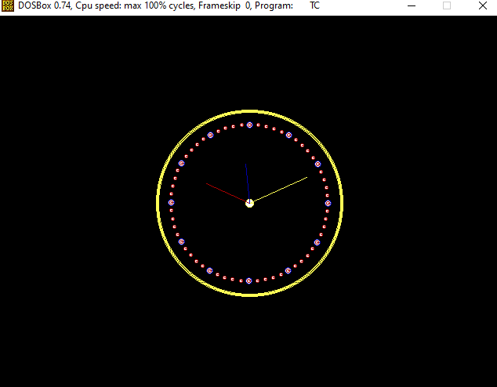

* **Conclusion and future scope**

This analog clock can be used on the front of the display when ever the desktop or phone goes to sleep mode. So if the user is somewhere out or in the classroom the user can just peek into their devices to view the time instead of operating the phone and getting distracted to view other notifications. In this way the user can save a lot of this daily time especially on mobile phones by reducing the screen on time.Nowadays many gadgets are coming with this feature known as always on display.

* **References**

<https://www.youtube.com/watch?v=QGKfQDf5n_I>

<https://blog.eduguru.in/tutorial/c-tutorial/graphics-program-in-c-for-analog-clock>

<https://www.instructables.com/id/Simple-Clock-in-language-C/>

<https://www.geeksforgeeks.org/c-program-print-digital-clock-current-time/>

Note:

* Report should be of 4-5 pages.
* Last date for submission : **31/03/2020** and upload the report in pdf format on the following link: https://drive.google.com/drive/folders/1Bv9U-

LRWMzlgTldG1ukKDaK4n95-bhJU?usp=sharing